Dewlers.com

Dewlers is a website and potential mobile app that allows people to make bets on anything. If you can do it someone else will most likely believe that you cant. “I can eat 10 hot dogs in 5 minutes”

The site will work as follows

1. Person registers
2. Creates a dewl
3. Enters Dewl details
   1. Title
   2. Details
   3. Amount to dewl
4. Picks whether it is a public or private dewl
   1. Public dewl is open to anyone, and normally shared on facebook, etc.
   2. Private Dewl is where the person creating the dewl selects one or more people to invite to the dewl.
      1. Private dewls can still be published on Facebook, etc. as a “call out” to the people invited
5. Confirms the Dewl
6. Invitee or public person click and accepts the dewl or alters terms.
7. Once terms are agreed on the dewl is official
8. A witness will need to be chosen to video and officiate the dewl
9. Witness either accepts or denies the dewl
10. Once a witness accepts the terms of the dewl, the dewl is ready
11. Dewl is performed and videoed by the witness
12. Video will be uploaded
13. Confirmation on dewl is done and winner is announced.

Here are the next steps for development

* Registration
  + Username: I would like that the user can pick a unique username during registration. We will need to validate that somehow.
  + Usernames after that will be signified with a dollar Sign($) in front of them (i.e. $derekgentry, $johnsmith176, etc) just like twitter and Instagram use @
  + Save the Latitiude and longitude into the tblUserDetails table for each user. This will be key for witness location later on.
  + The checkbox for I want to be a witness on the registration page should add their username to the tblUserDetails table
* Private Dewl
  + We need a screen that will allow the dewl creator to type a part of the username and a small picker window will show the top 5-10 usernames that match the string they are typing. Dynamic and fast is key here.  
    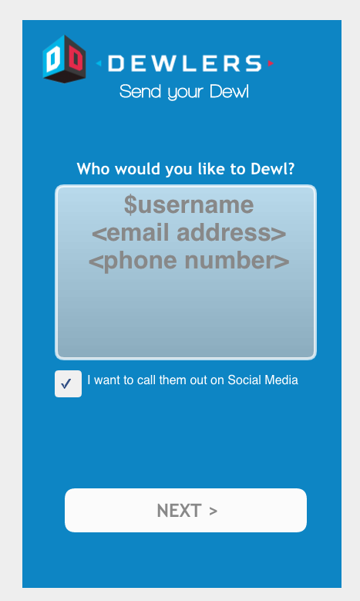
  + Invites will be stored in the tblDewlInvites table with DewlID, UserID
* Dewl Acceptance, denial or other
  + The following screen will be shown to a registered user when they click on a link to accept a dewl  
    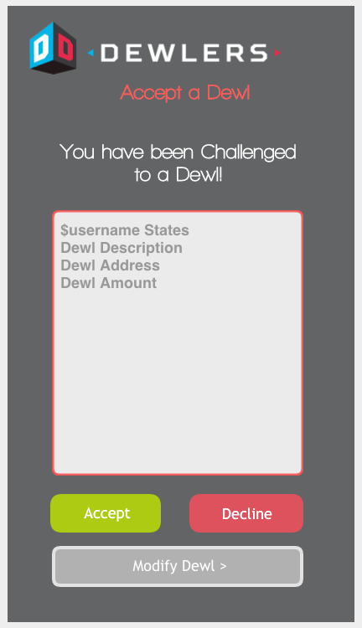
  + Whether they accept, deny or modify, the data will be updated in the tblDewlInvites table in the appropriate field
  + Accept or Deny is straight forward and the process stops at that point
  + Change will allow the user to modify the terms of the dewl.  
    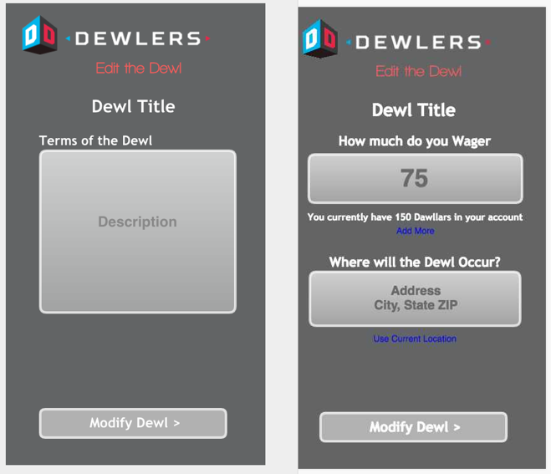  
    The details will be stored in the tblDewlMods table